Cargo Loading Optimization

Student name | ID
Basil Al Bhuji | 432111118
Marwan Al AEED | 431107769
Saleh Al ademi | 422116847



Supervisor:
المملكة العربية السعودية
وزارة التعليم
كلية الحاسب
قسم علوم الحاسب

Kingdom of Saudi Arabia
Ministry of Education
College of Computer
Computer science department

Table of Content
Table of Content 1
1-Problem Identification 2
1.1 What is Knapsack Problem 3
2-Algorithm Development 4
2.1 Introduction 5
2.2 Naive Algorithm 5-6
2.3 Optimized Algorithm 7-8
3-Implementation 9
2.1 Naive code 10
2.2 Optimized code 11
4-Theoretical Analysis 12
4.1 Naive Recursive Algorithm 13
4.2 Dynamic Programming Algorithm 13
4.3 Compare analysis 14w
5-Empirical Analysis 15
5.1 Naive Recursive Algorithm analysis 16
5.2 Dynamic Programming Algorithm analysis 17
6-Results Comparison 18
6.1 Theoretical vs. Empirical 19
6.2 Discrepancies and Explanations 20

1-Problem Identification

1.1 What is Knapsack Problem
Cargo transportation often involves selecting the most valuable combination of packages that can be loaded onto a truck with limited capacity. The challenge lies in making optimal use of space without exceeding weight restrictions while maximizing profit. This dilemma mirrors a classic combinatorial optimization problem known as the 0/1 Knapsack Problem.

Real-world challenge

In real-world logistics, decisions about which packages to load must balance value vs. weight, especially when handling high-volume shipments or restricted vehicle loads. This is not only a mathematical challenge but also a strategic planning issue that directly impacts delivery efficiency and cost-effectiveness.

The project aim

Our project aims to simulate this problem by designing two algorithmic solutions — a naive recursive approach and an optimized dynamic programming solution. Through this simulation, we seek to analyze and compare both methods, not just in theory but also by observing their real-time performance under worst-case input conditions. The ultimate goal is to demonstrate how algorithm choice affects system performance in practical applications such as cargo loading.

2-Algorithm Development

2.1 Introduction

To solve the Cargo Loading Optimization problem, we develop two algorithmic approaches: a naive recursive solution and an optimized dynamic programming (DP) solution. This dual approach allows us to contrast brute-force methodology with an efficient, structured strategy.

2.2 Naive Algorithm
The naive algorithm explores all possible subsets of packages and selects the one with the maximum total value without exceeding the weight limit.
How It Works:
- For each package, we decide whether to:
  - Include it (if it fits), or
  - Exclude it
- This decision is applied recursively to the remaining packages
- The result is the maximum value achievable under the weight constraint
Advantages:
- Simple and intuitive to implement
- A good teaching tool for understanding the nature of the problem
Limitations:
- Exponential time complexity: O(2ⁿ), where n is the number of packages
- Not scalable for large inputs (e.g., n > 30)

Pseudocode:
Function KnapsackRecursive(weights, values, capacity, index):
If index == 0 or capacity == 0:
Return 0

If weights[index - 1] > capacity:
// Cannot include the current item
Return KnapsackRecursive(weights, values, capacity, index - 1)

Else:
// Option 1: Exclude the current item
exclude = KnapsackRecursive(weights, values, capacity, index - 1)

// Option 2: Include the current item
include = values[index - 1] +
KnapsackRecursive(weights, values, capacity - weights[index - 1], index - 1)

// Return the maximum of both options
Return max(include, exclude)

2.3 Optimized Algorithm
The dynamic programming (DP) approach solves subproblems and stores intermediate results to avoid redundant computations.
How It Works:
- Create a 2D DP table dp[i][w], where:
  - i is the index of the current package
  - w is the current weight capacity
- Fill the table bottom-up:
  - If including the package gives more value than excluding it, store that value
  - Otherwise, carry forward the best value from the previous step
Advantages
- Polynomial time complexity: O(n × W)
- Efficient and scalable for large inputs
- Guarantees optimal solution
Limitations:
- Higher memory usage due to DP table
- Less intuitive than recursion for beginners

Pseudocode:
Function KnapsackDP(weights, values, capacity):
n = length of weights
Create a 2D array dp[n+1][capacity+1]

For i from 0 to n:
For w from 0 to capacity:
If i == 0 or w == 0:
dp[i][w] = 0
Else if weights[i - 1] <= w:
include = values[i - 1] + dp[i - 1][w - weights[i - 1]]
exclude = dp[i - 1][w]
dp[i][w] = max(include, exclude)
Else:
dp[i][w] = dp[i - 1][w]

Return dp[n][capacity]

3-Implementation

3.1 Naive code:
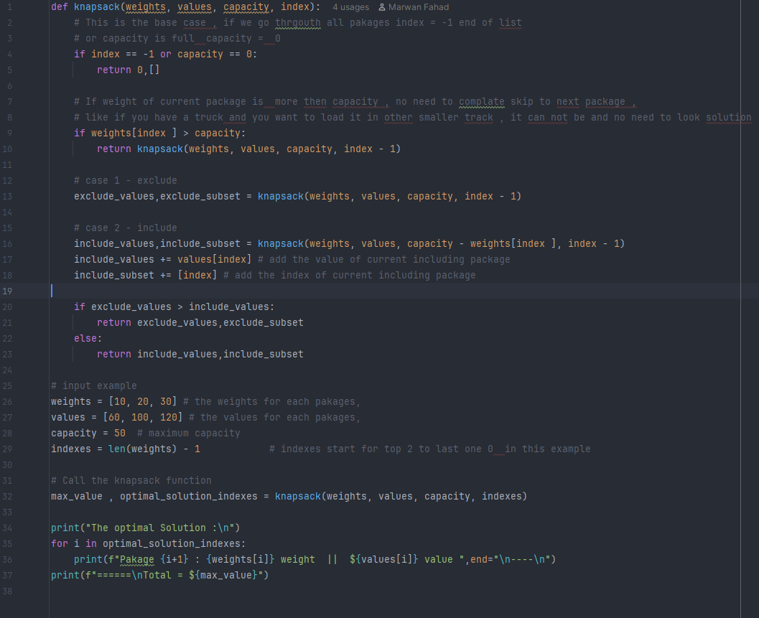

Output:
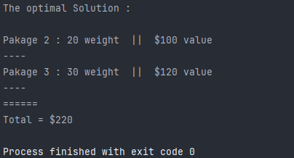

2.2 Optimized code:
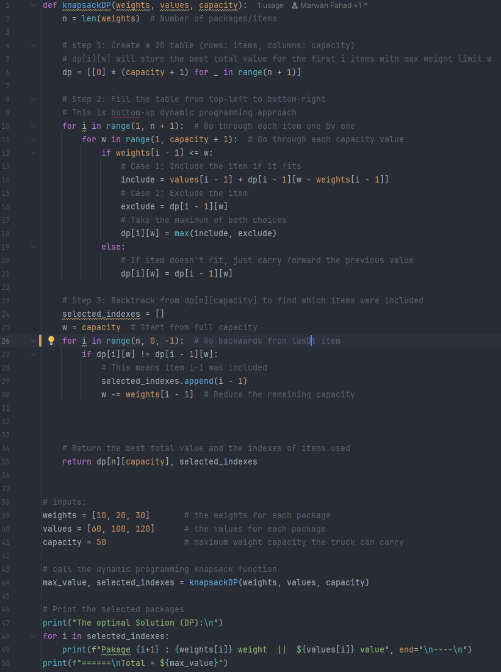
Output :

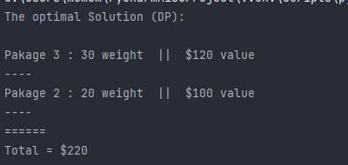

4-Theoretical Analysis

4.1 Naive Recursive Algorithm
- Time Complexity:
  - Each package leads to two recursive calls (include or exclude)
  - Total combinations: O(2ⁿ)
- Space Complexity:
  - Due to the recursion stack: O(n)
This algorithm is exponential and becomes impractical for large n.

4.2 Dynamic Programming Algorithm
- Time Complexity:
  - We fill a table of size n × W, where:
    - n: number of packages
    - W: weight capacity of the truck
  - Total operations: O(n × W)
- Space Complexity:
  - Using a 2D table: O(n × W)
  - Can be optimized to O(W) with a 1D array (space-optimized DP)
This algorithm is pseudo-polynomial — efficient when W is not very large.

4.3 Compare analysis

Aspect | Naive Recursive Algorithm | Dynamic Programming Algorithm
Approach | Brute-force recursion | Bottom-up table filling (memoized)
Time Complexity | O(2ⁿ) | O(n × W)
Space Complexity | O(n) (recursion stack) | O(n × W)
Optimality | Yes | Yes
Scalability | Poor (exponential growth) | Good for moderate W and n
Code Simplicity | Simple but inefficient | Slightly complex but efficient
Use Case | Small inputs (e.g., n ≤ 20) | Medium to large inputs (e.g., n ≤ 1000, W ≤ 10⁴)

5-Empirical Analysis

5.1 Naive Recursive Algorithm analysis
- We took the worst case of each input , the best way to analyse an algorithm
- The testing running time for different input examples :

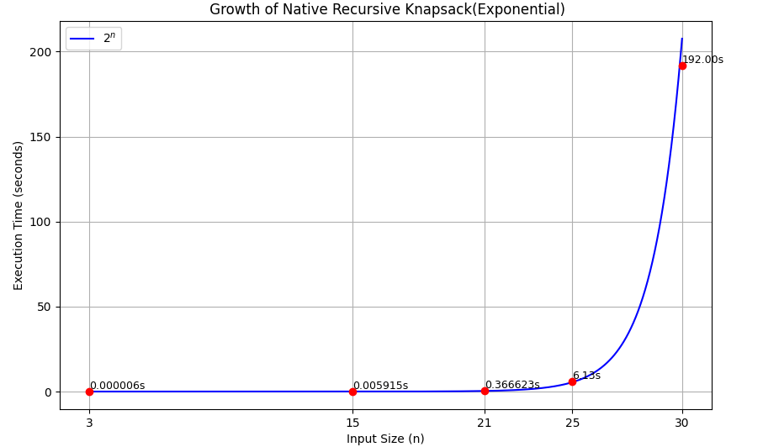

Becomes impractical for n > 25, as shown in the graph (192s at n=30).
5.2 Dynamic Programming Algorithm analysis
- We took the worst case of each input , the best way to analyse an algorithm
- The testing running time for different input examples :

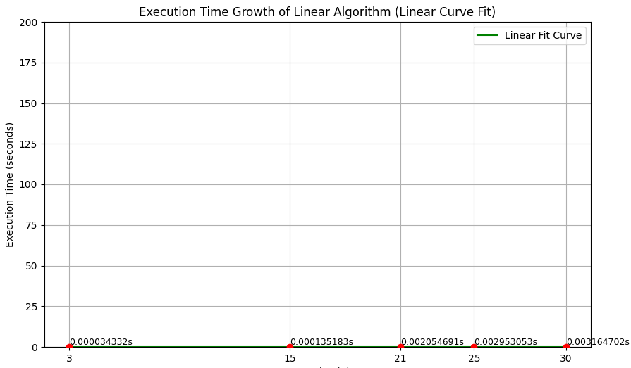
Highly efficient, even for larger inputs (e.g., 30,..).

6-Results Comparison

6.1 Theoretical vs. Empirical
- Comparison of Knapsack Algorithms: Recursive vs Bottom-Up DP with Theoretical explained above
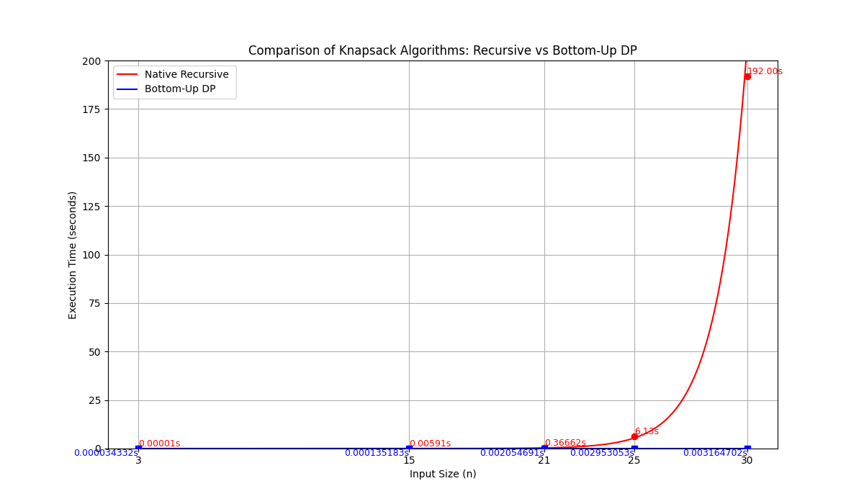
Naive Recursive Algorithm:
- Theoretical Time Complexity: O(2ⁿ)
- Empirical Results: As expected, execution time increases exponentially. It reached 192 seconds at input size n = 30, confirming the impracticality for large inputs.
Dynamic Programming Algorithm:
- Theoretical Time Complexity: O(n × W)
- Empirical Results: Execution time remained almost constant and extremely low even for larger inputs (e.g., 0.003s at n = 30), validating its efficiency and scalability.
Conclusion: Both algorithms' empirical performance closely matched their theoretical expectations, demonstrating the predictive power of algorithm analysis.
6.2 Discrepancies and Explanations
While the empirical results aligned well with theoretical expectations overall, a few minor discrepancies were observed:
- System Environment: Execution time may vary slightly due to CPU performance, memory availability, and background processes, especially for the recursive version which is sensitive to stack usage.
- Measurement Limitations: The time values are captured using Python’s time functions, which may introduce small inaccuracies due to rounding and system-level scheduling.
- Overhead in Recursive Calls: Recursive implementations incur additional overhead due to frequent function calls and deeper call stacks, making actual performance slightly worse than the ideal theoretical model.
Despite these minor factors, no significant deviation occurred. The empirical behavior still strongly reflects the expected exponential vs. polynomial complexity, clearly illustrating the performance gap between the two algorithms.

